16 L3 — Alignment Concern and Separate Fines Accumulation
L3 presents a different evidence relationship from that observed at U4. At the tail end, the available photograph shows an asymmetric belt/pulley relationship that is consistent with an alignment or tracking concern. The magnitude of this condition has not been measured and should therefore be confirmed through dimensional checks and representative operating observation.
Fines and material accumulation are also visible at several locations around the L3 conveyor and supporting structure. These deposits establish a separate material-loss condition; however, the available evidence does not show that the tail-end alignment condition is responsible for the observed fines accumulation or for significant coarse-product loss. The two conditions should therefore be assessed separately, with the alignment/tracking relationship quantified first and the fines condition then reassessed in the context of the verified operating condition.
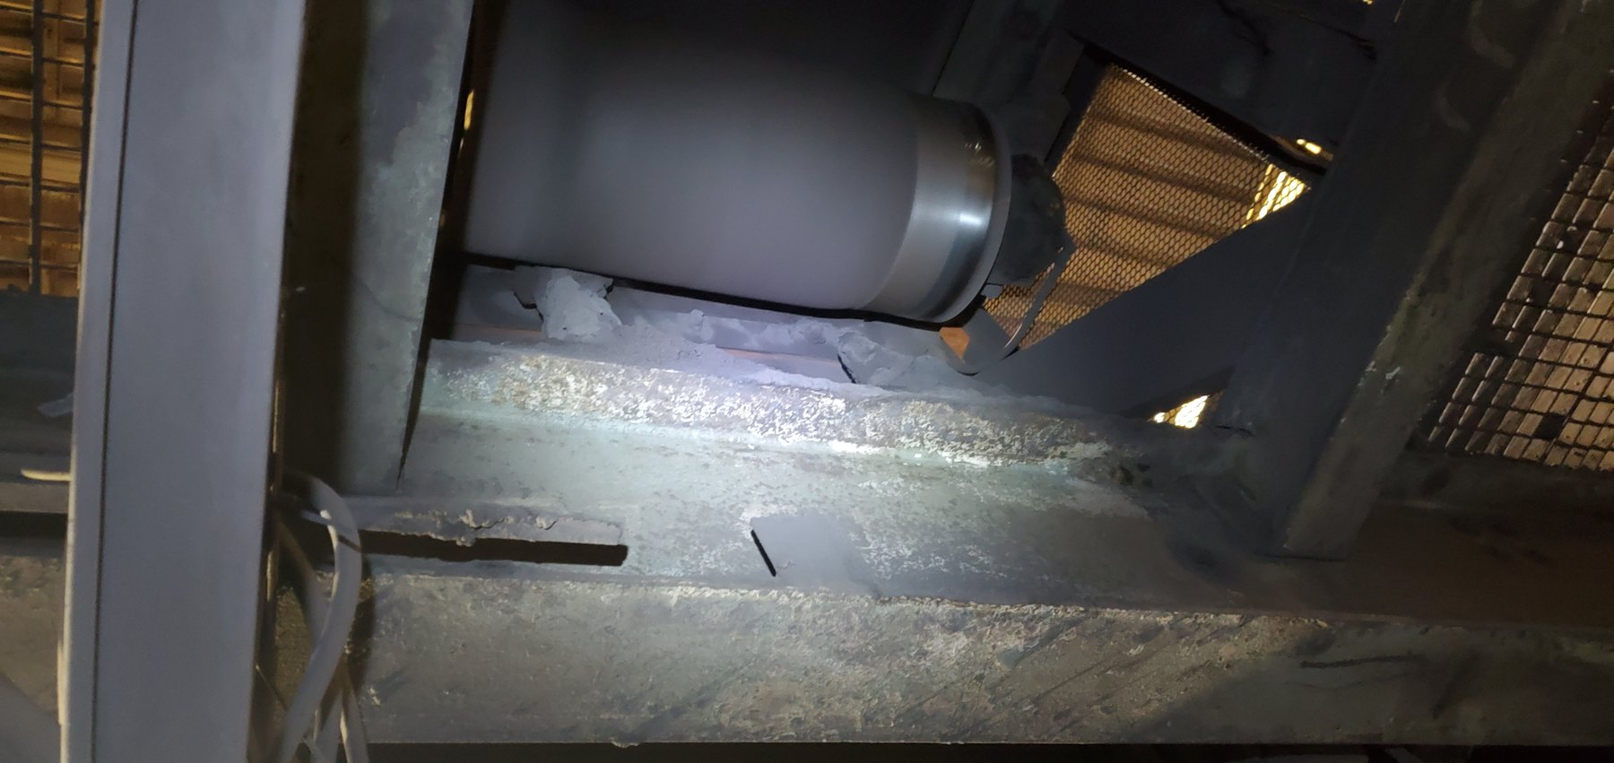
LoadoutStationL3-REF-001 — Tail-end view showing an asymmetric belt/pulley relationship consistent with an alignment or tracking concern. The magnitude of the condition remains unmeasured.
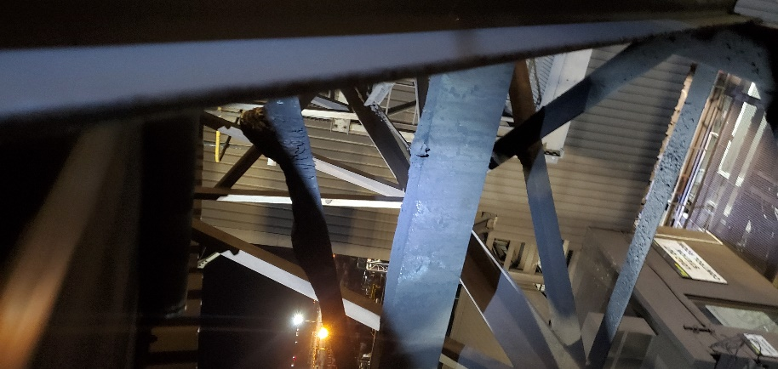  LoadoutStationL3-REF-004 — Additional view showing fines/material distributed around the local conveyor and support area. The photograph provides consequence context but does not establish the initiating source. | 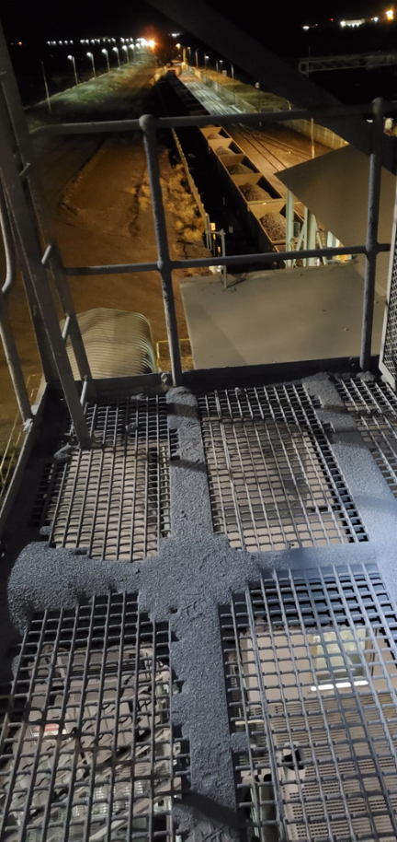  LoadoutStationL3-REF-007 — Close view showing substantial fine-material accumulation on the guarding and adjacent structure at L3.
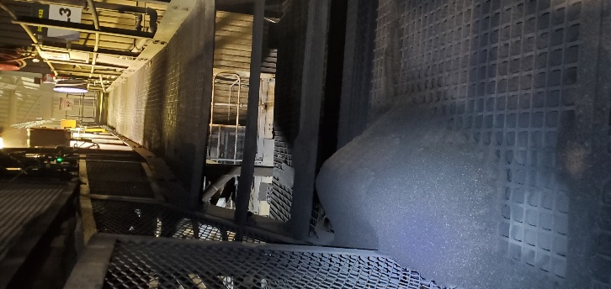  LoadoutStationL3-REF-002 — Fines/material accumulation around the L3 conveyor and guarding area, illustrating the separate fines-accumulation condition. | 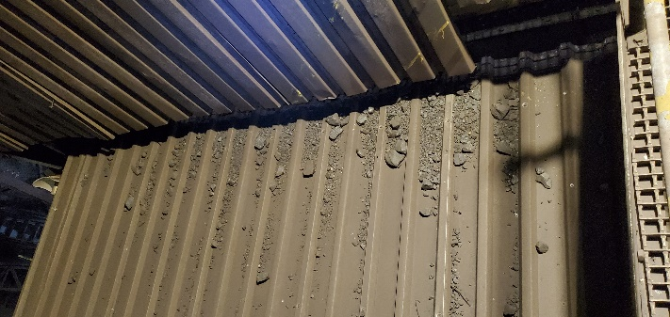  LoadoutStationL3-REF-008 — Supporting lower-area view showing fines and small-fragment accumulation beneath the conveyor.

